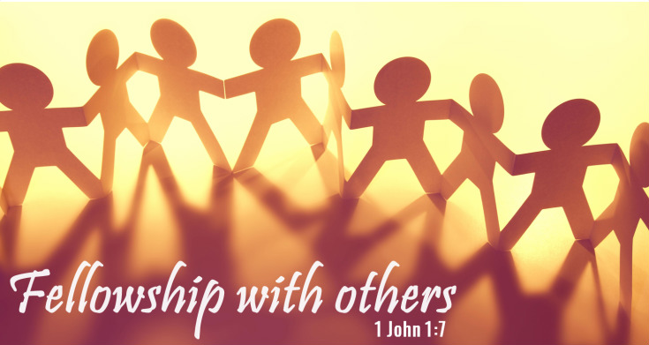

Refreshment Calendar: July-December 2026
Please set up and clean up when it’s your turn.
If you cannot attend on your Sunday,
trade with a friend from another group.

August 2  September 13  October 25  December 6  GROUP 1– JOY  Contact: Brie Noble 540-969-9523  Guest family  Watkinson family  Merritt family | August 9  September 20  November 1  December 13  GROUP 2 – PEACE  Contact: Lisa Haas 828-387-7788  McManus family  Vann family  Cohn family  Crymes family (winter) | July 5  August 16  September 27  November 8  December 20  GROUP 3 – PATIENCE  Contact: Patty Keeney 828-783-0824  Jones family (Robert/Steph)  Zimmer family  Jackie Kirkland  Jan Hamilton  Green Family (Summer)

July 12  August 23  October 4  November 15  December 27  GROUP 4 – KINDNESS  Contact: Teresa Taylor 828-504-0234  Phillips family  Brown family  Spears family  Bertini family | July 19  August 30 (Fifth Sunday)  October 11  November 22  GROUP 5 – GOODNESS  Contact: Karen Rominger 828-963-3115  Sandy Ramsey  Shipley family  Mark Smith family  Henson family  Ramona Steele (summer) | July 26  September 6  October 18  November 29 (Fifth Sunday)  GROUP 6– FAITHFULNESS  Contact: Barbara Cornett 828-898-7661  Josh Smith family  Cogdill family  Paul Smith family  Ava Walker

